**[How to Hide the Newsfeed, Skydrive and Sites buttons](https://sharepoint.rackspace.com/learning/articles/Pages/SharePoint-2013--how-to-hide-the-newsfeed-skydrive-and-sites-buttons.aspx)**

There are several reasons people may want to hide these features from their users whether it is for security or something else.  No matter what your reason, below are the simple steps you can take to hide/disable the Newsfeed, SkyDrive, and Sites buttons.

1. Open **SharePoint Designer 2013**. (If you do not have SharePoint Designer 2013 a free download can be found here: [**http://www.microsoft.com/en-ie/download/details.aspx?id=35491**](http://www.microsoft.com/en-ie/download/details.aspx?id=35491))
2. With SharePoint Designer 2013 open click **Open Site**.

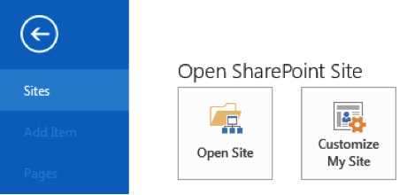

1. An Open Site window will appear, at the bottom in the Site name: section type your SharePoint URL. (For this demo I will be using [**https://spdemo.atrackspace.com**](https://spdemo.atrackspace.com/))  
   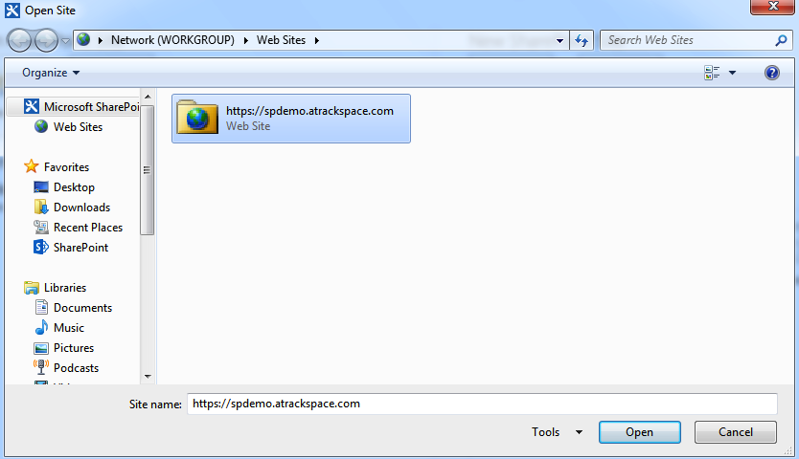
2. Click **Open**. (if you have never opened your site in SharePoint Designer 2013 the SharePoint login prompt will appear.  Click **Sign In to SharePoint** and enter your credentials.  You may receive an error, this is fine just click the red X to close the window and your site will open.)
3. In the left navigation click **Master Pages**.  
   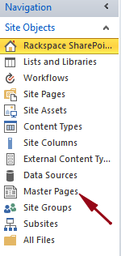
4. Click to the right of **seattle.master** to highlight it.  
   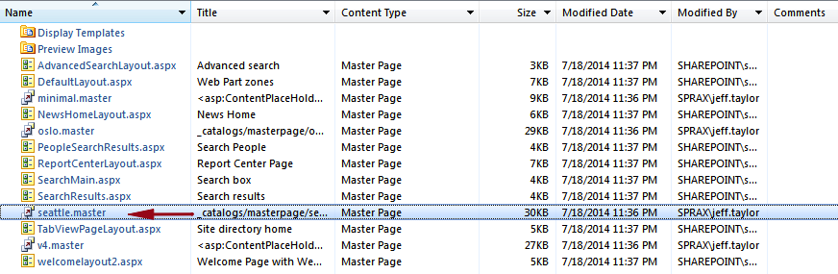
5. In the upper left hand corner of the page click **Copy**.  
   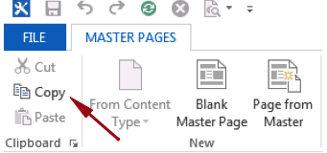
6. To deselect seattle.master click below the last item on the page, in this example case it is **welcomelayout2.aspx**.
7. In the upper left hand corner click **Paste**.  
   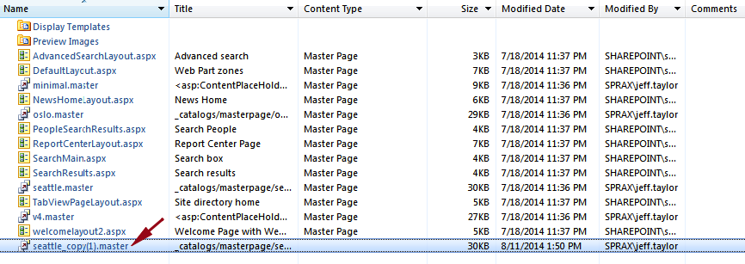
   * You have now created a copy of the master page, you never want to edit the default master page in case you need to go back for some reason.
8. Click the newly created master page **seattle_copy(1).master** .
9. On the seattle_copy(1).master page under Customization click **Edit file**.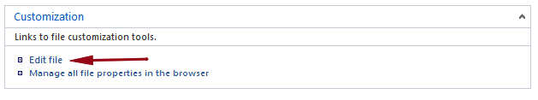
10. Scroll down to line 87 and delete the following text:
    * **<SharePoint:DelegateControl id="ID_SuiteLinksDelegate" ControlId="SuiteLinksDelegate" runat="server" />**
11. Your screen should now look similar to the screenshot below: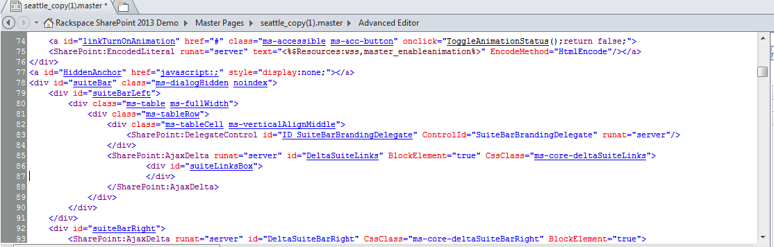
12. In the upper left hand corner click the **save** icon.
13. On the Site Definition Page Warning pop-up click **Yes**.
14. On the left navigation under Site Objects click **Master Pages**.
15. Locate the master page you were editing and click to the right of it to highlight.
16. At the top of the page click on **Set as Custom**, in the ribbon.  
    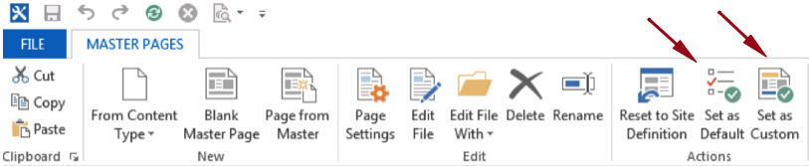
17. Right next to Set as Custom click **Set as Default**.
18. Go to your site and see the change, if you site is already open just refresh the page.

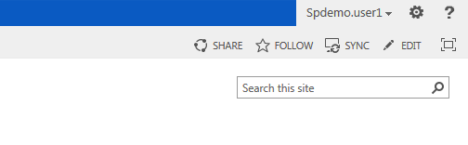

That’s it! You have now updated your master page for your site to hide Newsfeed, SkyDrive, and Sites.  This is a per site solution so if you create a new subsite you will need to apply this master page to those as well. 

Steps to apply this master page solution to a subsite:

1. With SharePoint designer still open copy the **seattle_copy(1).master** page.
2. In the upper left hand corner click **File**.
3. Click **Sites**.
4. Click **Open Site**.
5. This time enter the URL of your subsite.
6. Click **Open**.
7. If you have not opened the site before you will need to click **Open** a second time.
8. This should look very familiar, on the left navigation under Site Objects click **Master Pages**.
9. Right click anywhere in the middle open space and select **Paste**.
10. If of some reason your ribbon is not showing up no problem, right click on the newly pasted master page seattle_copy(1).master and select **Set as Default Master Page**.
11. Right Click the seattle_copy(1).master page again and select **Set as Custom Master Page**.

You have now applied your custom master page to your subsite.